CLASSIFYING PLANTS

Classification of plants is based on their complexity, which means how many different types of cells they have, and how they are arranged and used. The following features are used.

• Cell structure and function.
• Strength of the rigid cell wall made of cellulose.
• Presence or absence of an internal transport system.
• Method of reproduction.

All plants have the ability to photosynthesise using the chlorophyll in the chloroplasts within their cells. This produces food for the plant and oxygen for us.

H₂O + CO₂ food + O₂
Several phyla exist.

Mosses and Liverworts
• Simplest plants.
• Simple leaves and roots - no stem.
• Only a few millimetres high - no transport system inside.
• Live in moist places.
• Reproduce by spores.

Ferns
• Have roots, stem and leaves.
• Stem called rhizome which grows horizontally underground.
• Well developed transport system - tiny tubes carry water and nutrients around the plant.
• Means that ferns grow taller than mosses.
• Reproduce by spores.

Conifers and Cycads
• Well developed transport system.
• Reproduce by seeds (need male and female cones).
• Male cones are small, female cones are large.

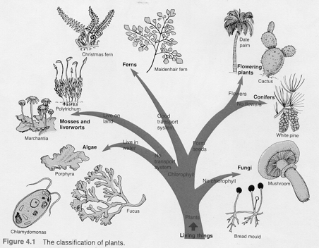
Flowering Plants
• Reproduce by seeds.
• Have male (pollen) and
female parts (ovules) of
flowers.
• Seeds develop inside a
fruit.

Below is a simple classification key for plants.

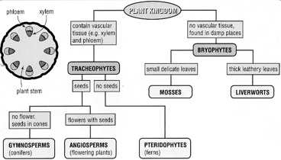

There are some organisms that don't fit into the plant classification.

Fungi
• Have a cell wall like plants.
• Don't have chlorophyll - can't photosynthesise.
• Feed on other plants and animals to survive - called heterotrophs.

Prokaryotes
• Includes all bacteria.
• Some are helpful - bacteria in the human stomach help digest food.
• Some are harmful - tetanus and tuberculosis can kill.

Protists
• Contain protozoa - single celled plants.
• Contain the algae (seaweeds).

